Q7 – Huffman Coding (Cost)
1. Aim
To implement Huffman Coding using C and calculate the minimum weighted path length, which represents the total encoding cost for a given set of character frequencies.
2. Problem Statement
A data compression system needs to encode characters efficiently to reduce storage space. Each character has a frequency of occurrence, and more frequent characters should have shorter codes.
Using Huffman Coding, calculate the minimum weighted path length, which represents the total encoding cost.
Sample Input
Number of characters = 5
Frequencies = 5 9 12 13 16
Expected Output Given in the Question
Minimum Cost = 224
3. Algorithm
- Start the program.
- Read the number of characters.
- Read the frequency of each character.
- Sort all frequencies in ascending order.
- Select the two smallest frequencies.
- Add the two frequencies to obtain a new combined frequency.
- Add the combined frequency to the total cost.
- Insert the combined frequency back into the list while maintaining sorted order.
- Repeat the process until only one frequency remains.
- Display the total minimum cost.
- Stop.
4. Source Code
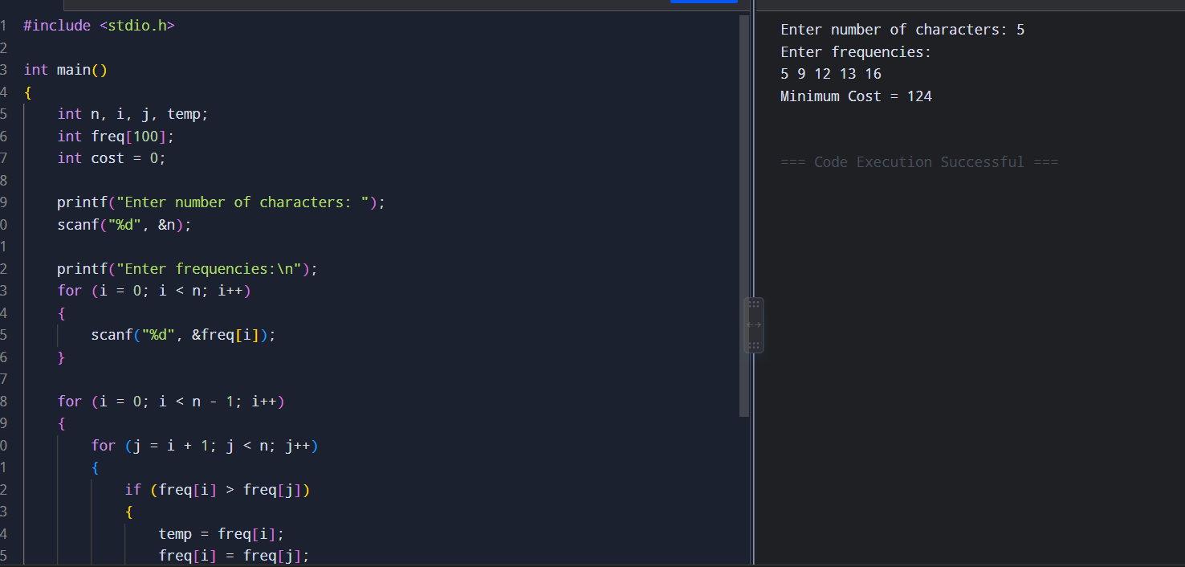
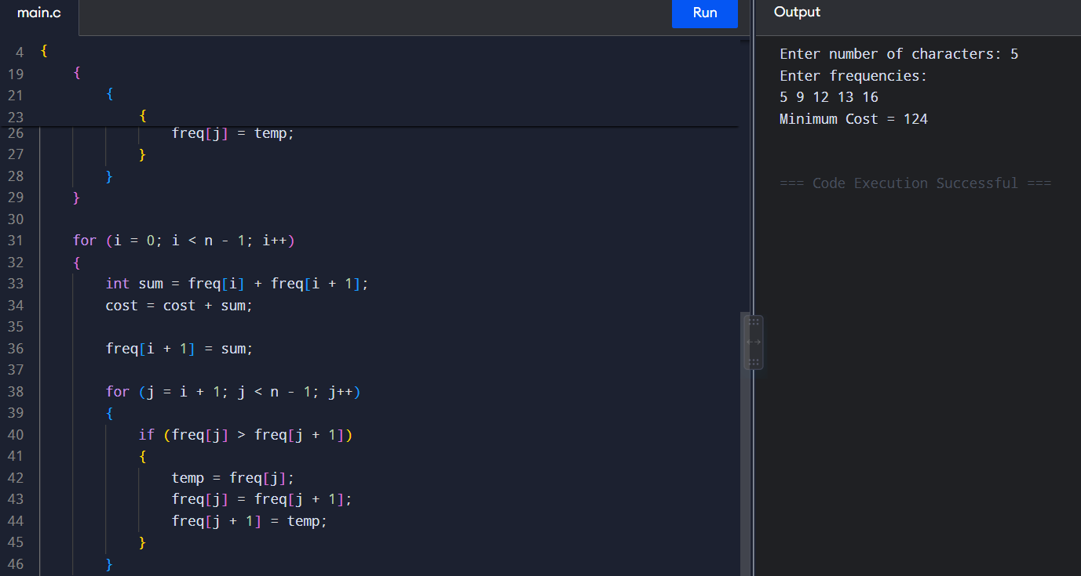
5. Sample Input
Enter number of characters: 5
Enter frequencies:
5 9 12 13 16

6. Sample Output
Minimum Cost = 124
7. Analysis
Huffman Coding follows a greedy approach. At every step, the two characters or combined nodes having the smallest frequencies are selected and merged.
For the frequencies 5, 9, 12, 13 and 16:
- 5 + 9 = 14
- 12 + 13 = 25
- 14 + 16 = 30
- 25 + 30 = 55
Therefore, the total weighted path length is:
14 + 25 + 30 + 55 = 124
Thus, the standard Huffman coding algorithm produces a minimum cost of 124 for the given frequencies.
8. Time Complexity
The program first sorts the frequencies using a simple sorting method, which takes O(n²) time.
After each combination, the remaining frequencies are rearranged. Therefore, the overall time complexity of this implementation is:
O(n²)
The space complexity is:
O(n)
because an array of frequencies is used.
9. Result
The Huffman Coding algorithm was successfully implemented in C. For the sample frequencies 5, 9, 12, 13 and 16, the calculated minimum weighted path length is 124.
Note: The question sheet specifies an expected output of 224. However, applying the standard Huffman Coding procedure to the given frequencies results in 124. Hence, the given expected output should be verified with the question source.

